**Skin Cancer Prediction**

1. **Team members -**

1. **Motivation -** The human body's largest organ, the skin, has a surface area of about 20 square feet. The primary functions of the skin are to assist the body control temperature, shield internal organs from bacteria and UV rays, and allow for perspiration, touch, heat, and cold feelings. Skin cancer incidence has been sharply rising in recent years. Melanoma is the most common cause. According to the World Health Organization, there were an estimated 232,000 documented cases of skin cancer worldwide. Additionally, it has been reported that the age difference and rate both rise globally each year. Therefore, it's crucial to start treating at an early stage since there is a significantly better probability of long-term survival.

1. **Significance -** One of the most serious types of cancer is skin cancer. Unrepaired DNA breaks in skin cells, which result in genetic flaws or mutations on the skin, are the primary cause of skin cancer. Because skin cancer is more treatable in its early stages and has a tendency to gradually spread to other body areas, it is best identified at an early stage. Early detection of skin cancer symptoms is necessary due to the rising incidence of cases, high death rate, and expensive medical treatments. Given the gravity of these problems, researchers have created a number of early-detection methods for skin cancer. Skin cancer is detected and benign skin cancer from melanoma is distinguished using lesion features including symmetry, color, size, form, etc.
2. **Objectives -** To accurately identify the type of cancer by carefully analyzing the photo of the lesion. We are attempting to distinguish between the many features in a snapshot of a cancer lesion in order to develop a model that will successfully classify them.
3. **Features -**
4. dx
5. dx_type
6. age
7. sex
8. localisation

1. **Related Work -**
2. **Skin Cancer Detection: A Review Using Deep Learning Techniques -** Different neural network algorithms for skin cancer detection and classification have been covered in this systematic review research. These methods are all non-invasive. The method of detecting skin cancer involves several steps, including preprocessing, image segmentation, feature extraction, and classification. The classification of lesion images using ANNs, CNNs, KNNs, and RBFNs was the main emphasis of this review. Each algorithm has benefits and drawbacks. The key to getting the best results is choosing the classification method correctly. However, because it is more closely tied to computer vision than other neural networks, CNN performs better than other types of neural networks when classifying picture data.
3. **A Survey On Diagnosis Of Skin Cancer Based On Image Processing Using Machine Learning -** Skin lesion diagnosis techniques integrated inside eHealth apps that support individuals and medical professionals are clearly needed as the prevalence of skin cancer rises. Melanoma is the most serious type of skin cancer, with an extremely poor chance of survival. Melanoma early identification may increase survival rates. This study provides a concise overview of how skin cancers function and are detected by many researchers, which is helpful for classifying normal and malignant skin cells.

1. **Dataset -** [Skin Cancer MNIST: HAM10000](https://www.kaggle.com/datasets/kmader/skin-cancer-mnist-ham10000)
2. **Detail Design of features -**
3. **dx -** Contains the type of lesion. Cases include a representative collection of all important diagnostic categories in the realm of pigmented lesions: Actinic keratoses and intraepithelial carcinoma / Bowen's disease (akiec), basal cell carcinoma (bcc), benign keratosis-like lesions (solar lentigines / seborrheic keratoses and lichen-planus like keratoses, bkl), dermatofibroma (df), melanoma (mel), melanocytic nevi (nv) and vascular lesions (angiomas, angiokeratomas, pyogenic granulomas and hemorrhage, vasc).
4. **dx_type -** Tells us how did the lesion got confirmed. More than 50% of lesions are confirmed through histopathology (histo), the ground truth for the rest of the cases is either follow-up examination (follow_up), expert consensus (consensus), or confirmation by in-vivo confocal microscopy (confocal).
5. **Gender -** The Gender of the person (male/female)
6. **Age -** The age of the person
7. **Localization -** Where is the lesion situated (e.g., scalp, ear, etc.)
8. **Analysis -**

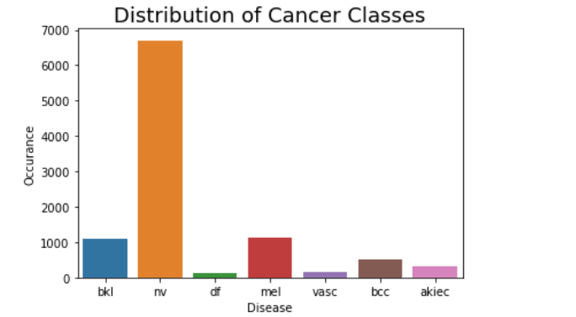

Graph on Distribution of different Cancer Classes

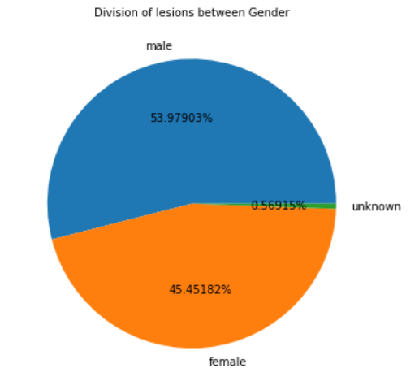

Gender division affected by different cancers

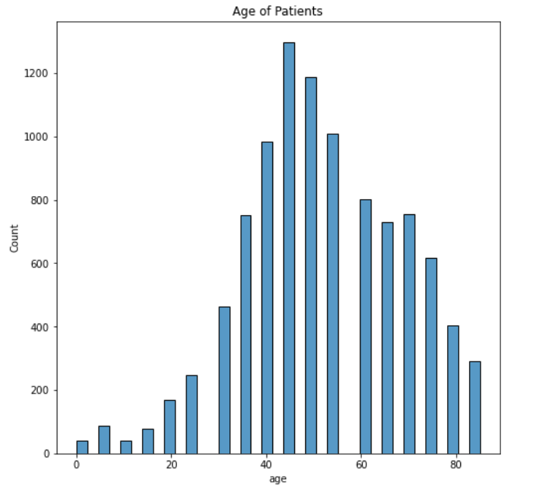

Age vs Number of patients of that age

1. **Implementation -**

Analysis -

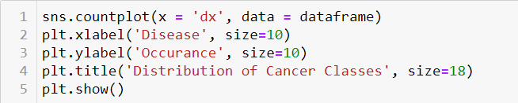

Cancer classes Graph



Cancer occurrence in males and females

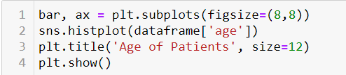

Number of people affected at different ages

1. **Preliminary Results -**
2. melanocytic nevi (nv) is the most prominent type of cancer lesion
3. The dataset contains around 54% males and 45.5% females.
4. Most Patients are between the age of 30 and 70 with 45 having the most
5. **Project Management -**
6. **Work Completed -** The dataset loading, customization, preprocessing, exploratory data analysis of features, and preparation of training and testing data are done.
7. Loading and preprocessing of CSV file -
8. Loading and preprocessing of the images -
9. Cancer Classes Analysis -
10. Gender distribution Analysis -
11. Age Count Analysis -
12. Preparing training and testing data -
13. **Work to be Completed -** The model is to be built with the features analysed, trained, tested and analysed.
14. Model Building
15. Training and testing the Model
16. Results and analysis of testing data

1. **References -**
2. [Dataset](https://www.kaggle.com/datasets/kmader/skin-cancer-mnist-ham10000)
3. [Skin Cancer Detection: A Review using Deep Learning Techniques](https://www.mdpi.com/1660-4601/18/10/5479/htm)
4. [A Survey On Diagnosis Of Skin Cancer Based On Image Processing Using Machine Learning](https://ijcrt.org/papers/IJCRT2106191.pdf)